**Flowchart Representation**

1. ***Insert Contact***

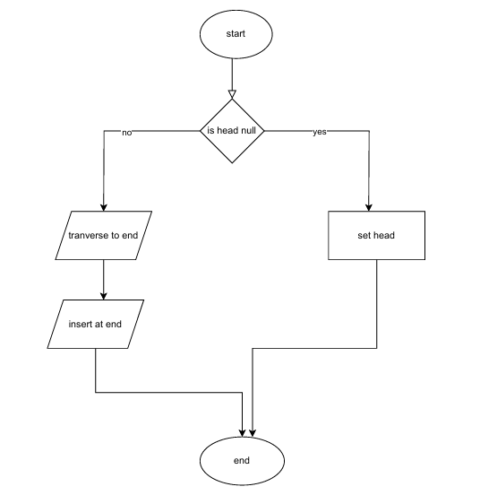

1. ***Search Contact***

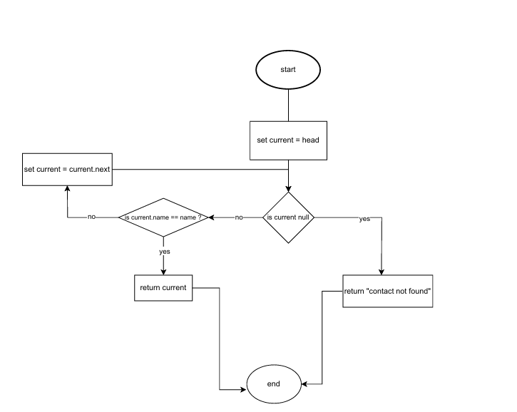

1. ***Display All Contacts***

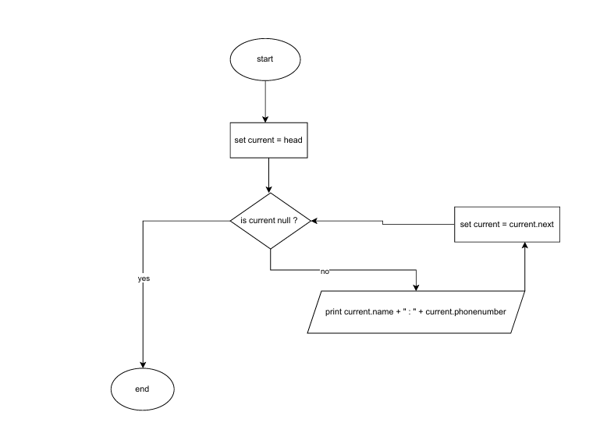

1. ***Delete Contact***

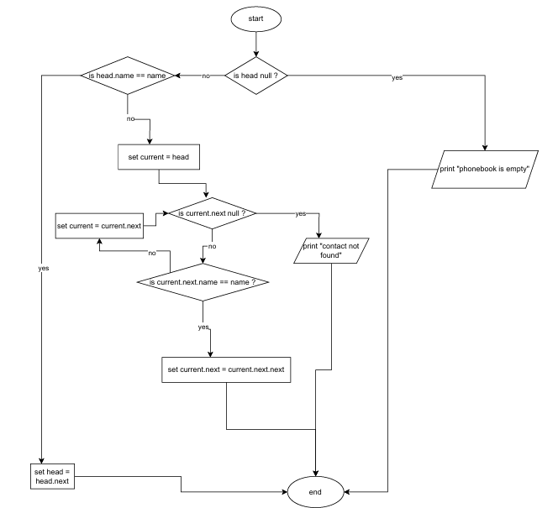

1. **Update Contact**

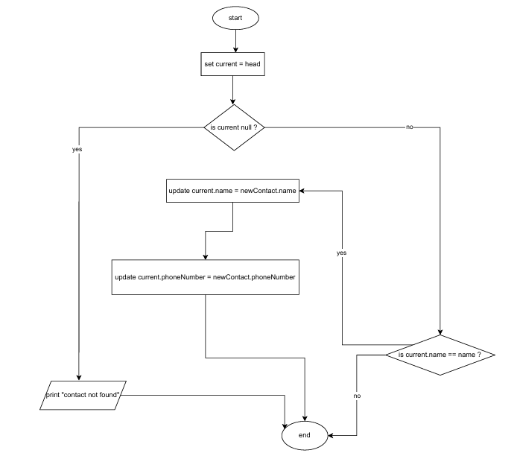

1. ***Sort Contacts (optional)***
2. **For sorted contacts(lone diagram)**

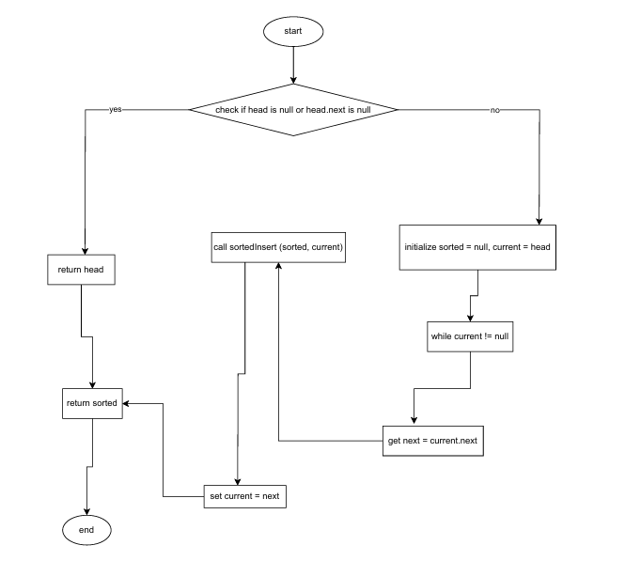

1. **For SortedInsert**

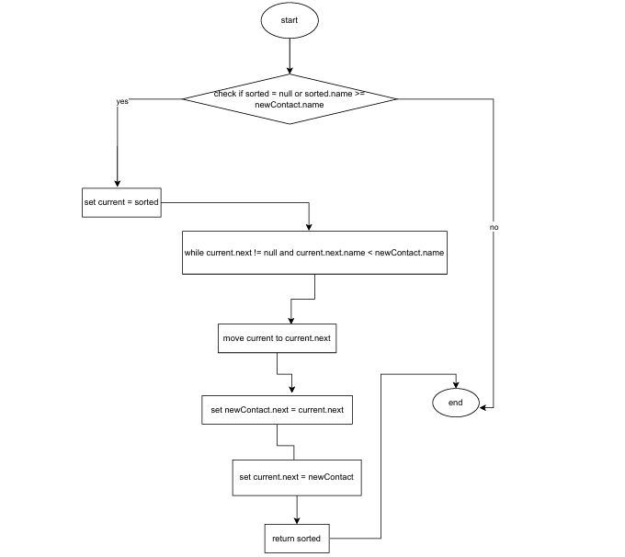

***7.Analyze Search Efficiency***

